Room A
AQ1 GI Leak in Bariatric Surgery.
Stem: A 45-year-old male presents to the emergency room with left chest and back pain, nausea, shortness of breath, and subjective fever. He underwent an uncomplicated laparoscopic bariatric procedure 10 days earlier in another hospital, and his current body mass index (BMI) is 58 m/kg2.
PE: Diaphoretic. Vitals: Temp 38.5°C, HR 114, Bl.Pr 114/75, RR 20, O2 94%. Abdomen is nontender and incision sites are dry and intact without signs of erythema or drainage.
PMH/PSH: GERD, HTN, Hyperlipidemia, COPD, appendectomy.
Social History: Prior smoker, drinks EtOH weekly.
Meds: Metformin.
Family history: Unremarkable.

Labs: CBC (WBC 18000, H&H 11/32) BMP (Na 144, k 4.5, Cl 98, Cr 2.9) Troponin Normal. Lactate 3.9.

What is your Differential Diagnosis?
- GI leak.
- Postoperative bleeding.
- Missed bowel injury.
- Missed pancreatic injury.
- PE.
- MI
What would you like to do now?
- Resuscitation: Two wide bore IV cannulas, IVF, Broad spectrum Abx.
- Obtain operative report.
- CT Abdomen and pelvis: What Contrast? Oral.
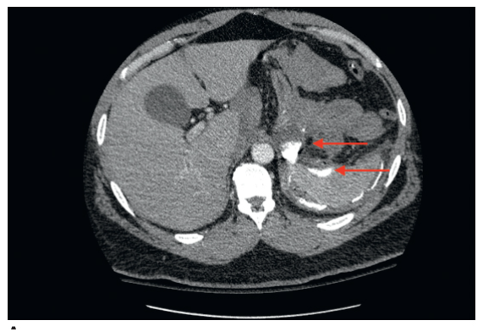

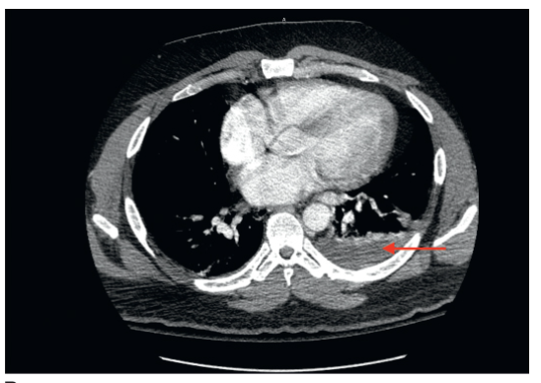
Contrast extravasation and extraluminal air along with a complex fluid collection located in the left subdiaphragmatic space.
You obtain and review the operative report, patient procedure was sleeve gastrectomy, what is your diagnosis in this case and how would you proceed?
- Gastric staple line leak, presenting with sepsis.
- Laparoscopic exploration. (Preferred) for irrigation and Drainage.
Describe how you would perform the procedure.
- Veress needle at Palmer’s point. Port is placed in the left upper quadrant. Angled laparoscope (5 or 10 mm)
- The patient is placed in the steep reverse Trendelenburg position, and additional ports are placed.
- Careful exploration of the left upper quadrant with blunt atraumatic graspers.
- Identify and drain any abscess cavity.
- Irrigate copiously with warm saline.
- Place one or more drains into the cavity spaces.
(Examiner please note, Identification of the exact location of the leak is not necessary as primary repair is often not feasible, and narrowing by overzealous attempts at repair of a sleeve or gastric bypass pouch leak can result in a stricture.)
- You identify the leak site, now what? Omental patch, placing seromuscular sutures through healthy gastric tissue and omentum.

- Consider placing feeding jejunostomy. Describe?
  - Place four sutures (2-0 braided absorbable sutures are used typically) in a diamond formation along the antimesenteric portion of the small bowel.
  - Enterotomy is created in the middle of the four sutures.
  - 12- to 14-Fr silastic feeding tube is advanced into the bowel directing it distally along the jejunum.
  - The four sutures are anchored to the abdominal wall
  - The drain is then sutured to the skin with a 3-0 nylon suture.
What are some protentional complications that can occur during or following this takeback surgery?
- Splenic injury
- Pancreatic injury.
- Splenic flexure colon injury.
- Gastrocolic fistulas
- Chronic fistula from leak site.
This patient is now 3 weeks post op, tolerating jejunostomy tube feeds well, doing well but with persistent gastric secretions through the drains, now what?
Endoscopic Stent Placement.
Is there a role for non-operative management?
Yes, clinically stable patients.
How?
- CT drainage.
- Endoluminal Stents.
What are the complications of endoluminal stents?
- Migration.
- Kniking.
- Erosion.
- Patient intolerance.
How long you would expect for a leak to seal non operatively for gastric bypass?
4-6 weeks for gastric bypass.
What about sleeve gastrectomy?
4-6 weeks but can be longer due to high pressure from the stomach.

AQ2 Splenectomy ITP
Stem: A 44-year-old female presented to her primary care doctor several months ago complaining of a recent onset of easy bruising and gum bleeding. Workup demonstrated a platelet count <10 × 109/L. She was diagnosed with immune thrombocytopenic purpura (ITP) and admitted to the hospital for treatment. She was palced on high-dose intravenous immunoglobulin and high-dose corticosteroids with an excellent response in her platelet count. She was discharged home on a gradual prednisone taper. As her prednisone doses were weaned below 20 mg per day, the patient experienced a recurrence in her thrombocytopenia with associated recurrence of easy bruising.
What is your diagnosis and management plan?
- Refractory ITP.
- Bone marrow aspiration: normal marrow cellularity, adequate megakaryocytes. Review of the peripheral blood smear does not demonstrate platelet clumping.
- Splenectomy: After administration of splenectomy vaccines preop.
  - pneumococcal vaccine (PCV13), Haemophilus influenzae type b vaccination (Hib), and meningococca
Patient came to you because you perform minimal invasive procedures, you agree, How would you perform her surgery? (Resident to describe one minimal invasive approach, Patients with ITP are ideal candidates for a minimally invasive approach because they are frequently young, otherwise healthy patients with normal-sized spleens.)
- Laparoscopic: Describe?
  - Patient positioned in modified right lateral decubitus position.
  - Abdominal access
  - Ports are placed as :
    - 12-mm trocar ~3–4 cm below the left costal margin in the midclavicular line.
    - Two 5-mm trocars are placed along the costal margin between xiphoid process and 12 mm trocar.
  - Divide the splenocolic ligament and mobilize the splenic flexure caudad.
  - Additional 12-mm trocar is placed in the left anterior axillary line below the costal margin.
  - The short gastric vessels are divided in their entirety up to the level of the superior pole of the spleen.
  - Mobilize inferior pole of the spleen by dividing splenorenal ligament.
  - Mobilize the superior pole of the spleen to isolate the splenic hilum.
  - The splenic hilar vessels are divided with an endoscopic stapler.
  - Spleen is placed in endobag, which is exteriorized through the Hasson trocar site so the spleen can be morcellated.
  - Upon completion, the abdomen is then reinspected laparoscopically to ensure hemostasis.

- Hand Assisted laparoscopic Splenectomy.
  - Patient is positioned in modified right lateral decubitus position.
  - Abdominal access
  - Ports are placed as :
    - 12-mm trocar ~3–4 cm below the left costal margin in the midclavicular line.
    - Two 5-mm trocars are placed along the costal margin between xiphoid process and 12 mm trocar.
  - Divide the splenocolic ligament and mobilize the splenic flexure caudad.
  - Additional 12-mm trocar is placed in the left anterior axillary line below the costal margin.
  - The short gastric vessels are divided in their entirety up to the level of the superior pole of the spleen.
  - Connect the 5-mm skin incisions and open the subcutaneous tissue and fascia.
  - Place hand port. Utilize left hand to protect and retract the spleen and the right hand to use dissecting instruments.
  - Mobilize inferior pole of the spleen by dividing splenorenal ligament.
  - Mobilize the superior pole of the spleen to isolate the splenic hilum.
  - The splenic hilar vessels are divided with an endoscopic stapler.
  - Spleen placed in large endobag or sterile x-ray cassette cover and exteriorized through the hand-port site, so the spleen can be morcellated or removed in its entirety.
When is splenectomy indicated for ITP?
- Episodes of severe bleeding related to thrombocytopenia.
- Patients who fail to respond to 4 to 6 weeks of medical therap.
- Patients who require toxic doses of immunosuppressive medication to achieve remission.
- Patients who relapse following an initial response to steroids.

AQ3 Intussusception

Stem: 8 month old male, otherwise healthy presenting about a week after an upper respiratory infection with 6 hours of intermittent crying and bringing his legs to his chest followed by vomiting. In between the episodes he acts normal and playful. Vital signs are within normal limits, he has no previous surgical or medical history. Physical exam demonstrates no evidence of inguinal or umbilical hernias, palpable mass in the right mid abdomen on abdominal exam, non-peritoneal.
KUB demonstrates dilated small bowel loops with air-fluid levels

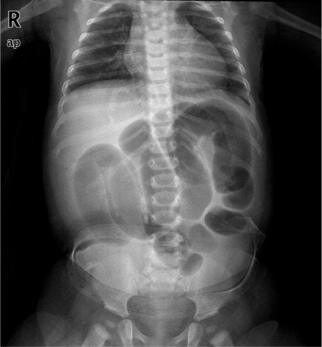

What is your Differential Diagnosis?
1.Intussusception
2. Constipation
3.Meckel’s diverticulitis
4.Appendicitis Gastroenteritis
What additional Workup or Studies?
US of the right lower quadrant demonstrates a target sign suggestive of intussusception.

What would you like to do now?

- IV access, 20 ml/kg bolus of NS
- Obtain an air-contrast enema for reduction of the intussusception.

What If recurs?
- Repeat enema process.

What if unable to reduce the ileocecal intussusception with air contrast enema?

- OR for exploratory laparotomy through transverse RLQ incision
  - Place NG tube
  - Milk the intussusceptum retrograde into the proximal bowel with slow constant squeezing,
(NOT only pull on the proximal bowel to reduce it)

Still unable to reduce? Resection with primary anastomosis

Scenario 2: Same patient with two days of intermittent pain, bloody-mucous stools, now with tachycardia, distention, and involuntary guarding on abdominal exam?
- OR for exploratory laparotomy.

